**OOSD Project Documentation**

An Object-Oriented Application for Managing

Customers, Products, and Invoices



**Module Name:** OOSD

**Lecturer:** Dr. Jason Barron

**Course Code:** CW_KCSOF_B

**Name:** Amelia Hamulewicz

**Student ID:** C00296605

**Date of Submission:** 10 April 2025

Table of Contents

Description 3

Overview 3

**Main Features** 3

**Technologies Used** 4

Requirements 5

Screenshot Database Table (Structure and Data) 6

Customer Table 6

Product Table 6

Invoice Table 7

Invoice Item Table 7

ER DIAGRAM 8

Interesting Source Code Snippets 9

Validation 9

Confirm Before Submission / Event handling GUI 10

Product Categories list dropdown 11

Updating stock in the product table when item/s are added into invoice table: 12

Tests 13

**1.** **Product Management** 13

**2.** **Customer Management** 13

**3.** **Invoice Management** 13

**4.** **Input Validation & Error Handling** 14

**5.** **Filtering and Viewing** 14

# **Description**

## **Overview**

This project is a desktop app for managing products, customers, and invoices. It was built using Java Swing for the GUI and JDBC (Java Data Base Connection) to connect to a database. Users can add, edit, view, and delete products, customers, and invoices. The app works with a database that has at least three tables: Customer, Product, and Invoice.

### **Main Features**

* **Product Management:**  
  Users can add new products, update existing product details, delete products, and view a full list of all products.
* **Customer Management:**  
  The application allows users to manage customer records, including adding, editing, and deleting customer information. Input validation ensures the data entered is correct and complete.
* **Invoice Creation:**  
  Users can create new invoices, add or remove products from an invoice, and the system automatically updates stock levels based on item quantities.
* **Filtering and Searching:**  
  Products and invoices can be filtered by category or customer to make it easier to find specific information.
* **Validation and Error Handling:**  
  The system includes checks to ensure valid input, such as making sure prices and stock quantities are non-negative numbers. Errors are handled gracefully with clear messages.
* **Graphical User Interface (GUI):**  
  The interface is built using Java Swing components such as JTable, JTextField, JComboBox, and JButton, offering a user-friendly and interactive experience.

### **Technologies Used**

* **Java (JDK 8):**  
  The core programming language used to develop the application, following object-oriented principles.
* **Java Swing:**  
  Used to build the graphical user interface, including forms, tables, buttons, and input fields.
* **JDBC (Java Database Connectivity):**  
  Enables the application to connect to and interact with a relational database through SQL queries.
* **SQL ( MySQL ):**  
  Used for creating and managing the database tables, as well as executing queries for storing and retrieving data.

# **Requirements**

**Backend Requirements**

* The system uses a **relational database** (e.g. MySQL or MariaDB).
* The database must contain at least **three tables**:  
  Customer, Product, and Invoice.
* Tables are linked using **foreign keys**, and at least one **INNER JOIN** is used for queries (e.g. loading invoice details with customer info).
* A **JDBC driver** must be available to allow the Java app to connect to the database.

**Frontend Requirements**

* The user interface is built with **Java Swing**, using components such as JButton, JTable, JComboBox, and JTextField.
* Users should be able to **create**, **view**, **update**, and **delete** products, customers, and invoices.
* Input fields must include **validation** to prevent invalid data (e.g. letters in number fields, empty fields, etc.).
* Error messages are displayed clearly when something goes wrong.

**System & Setup**

* **Java JDK 8 or higher** must be installed on the system.
* The system should support **Windows, macOS, or Linux**.
* Database connection details (host, username, password) are handled in the MyConnection class.

# **Screenshot Database Table (Structure and Data)**

## **Customer Table**

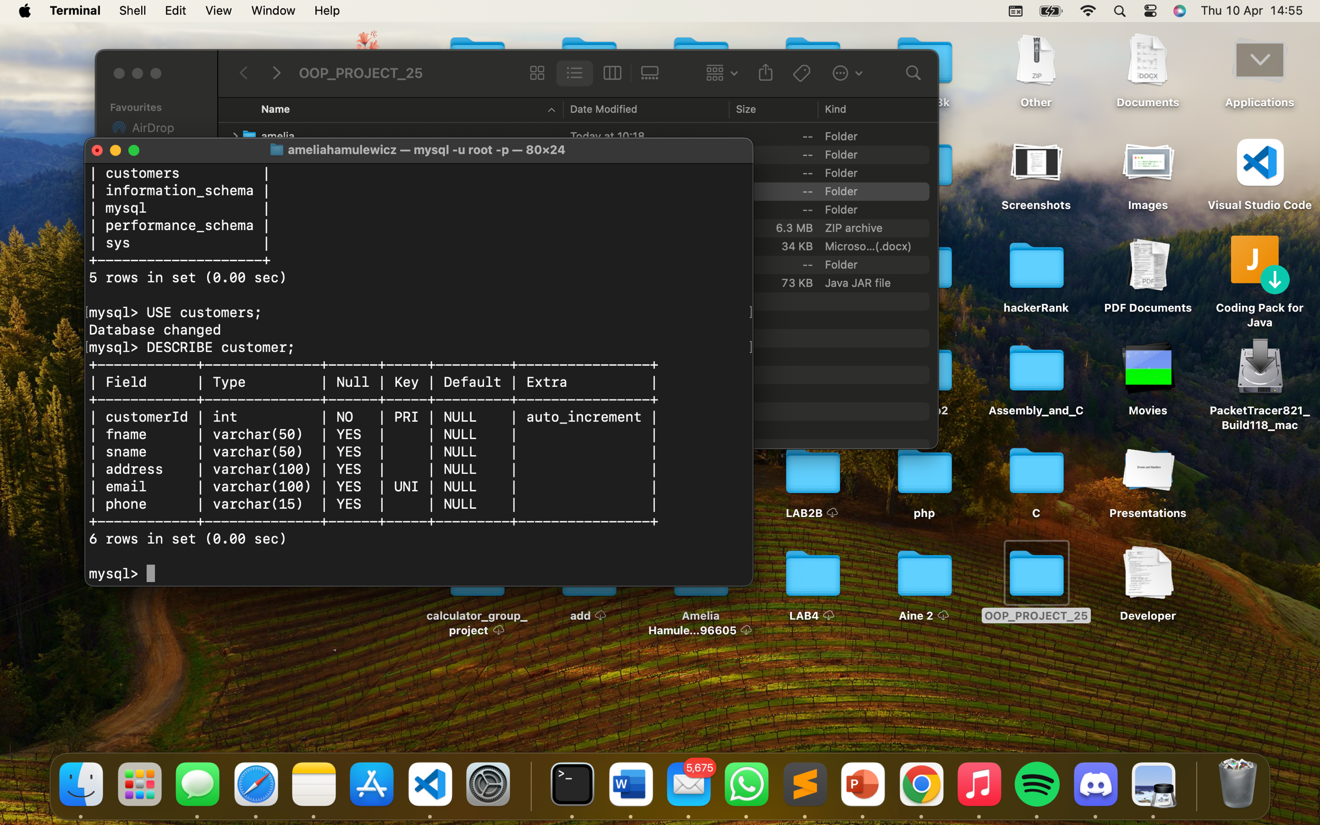

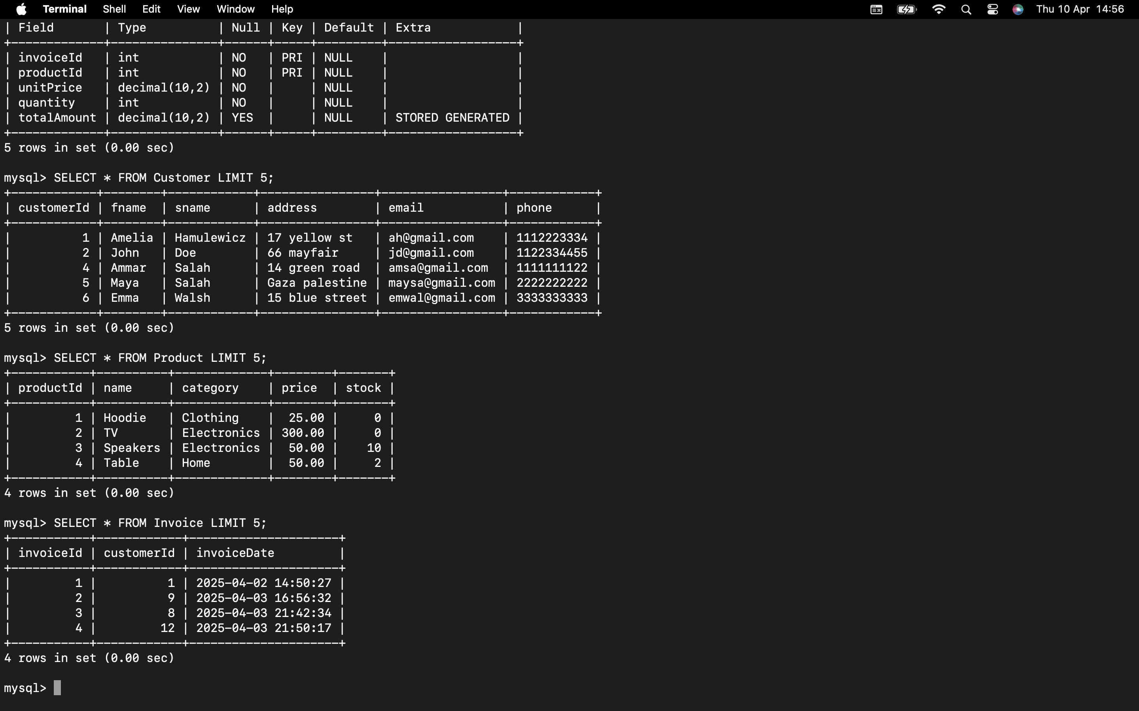

## **Product Table**

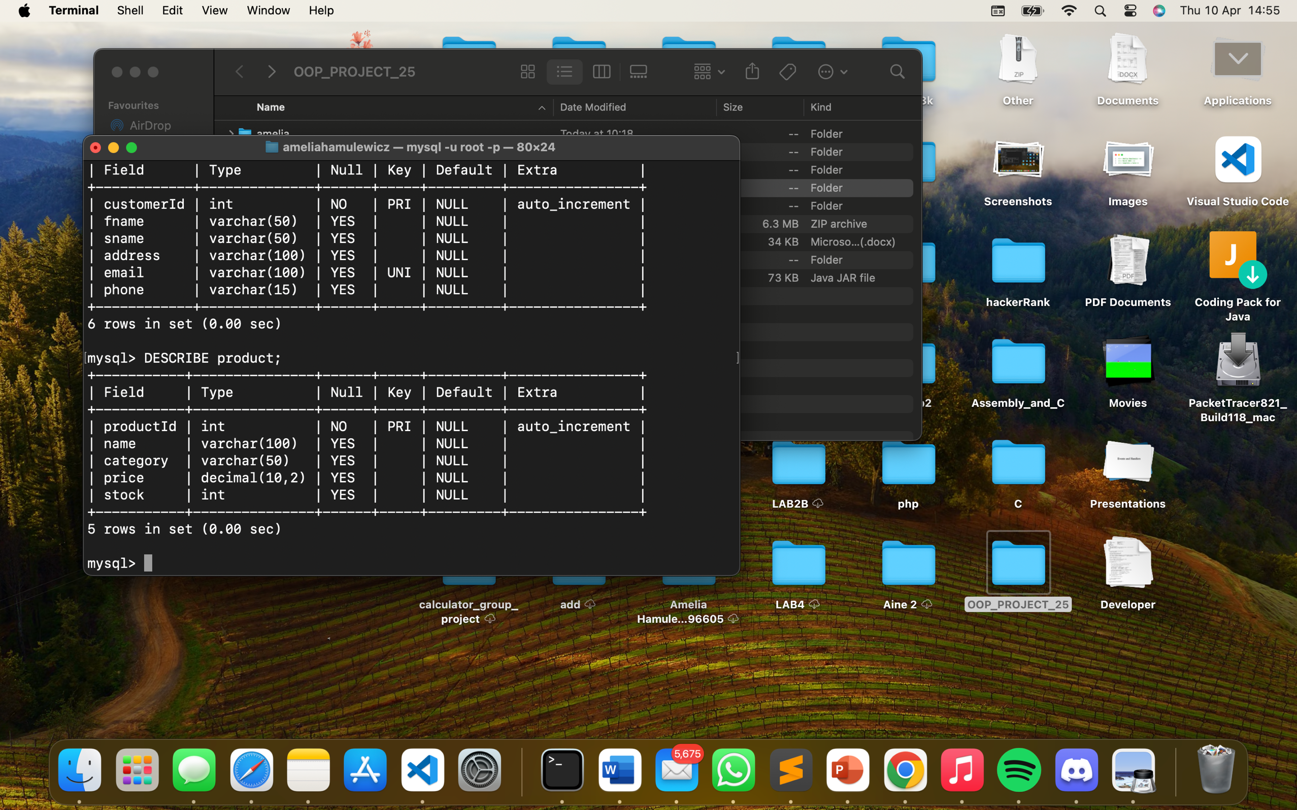



## **Invoice Table**

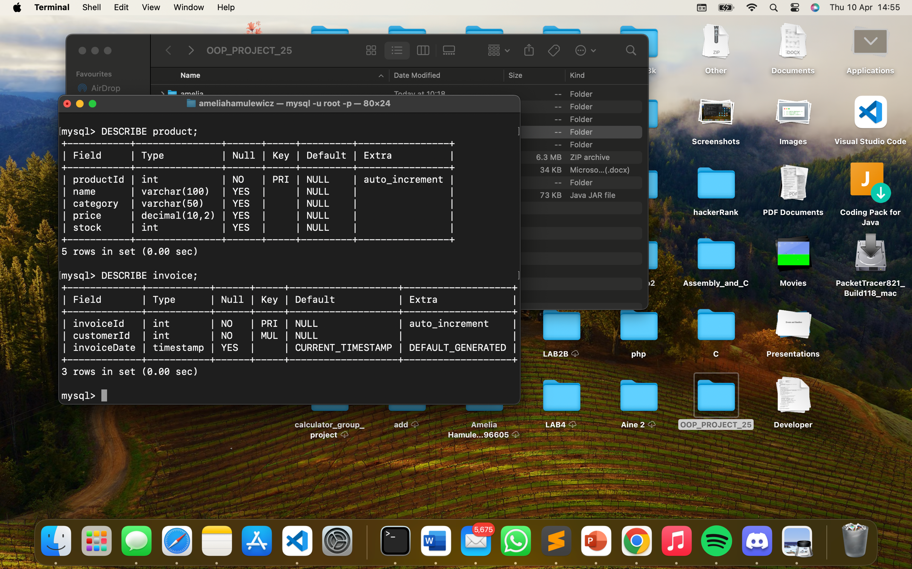



## **Invoice Item Table**

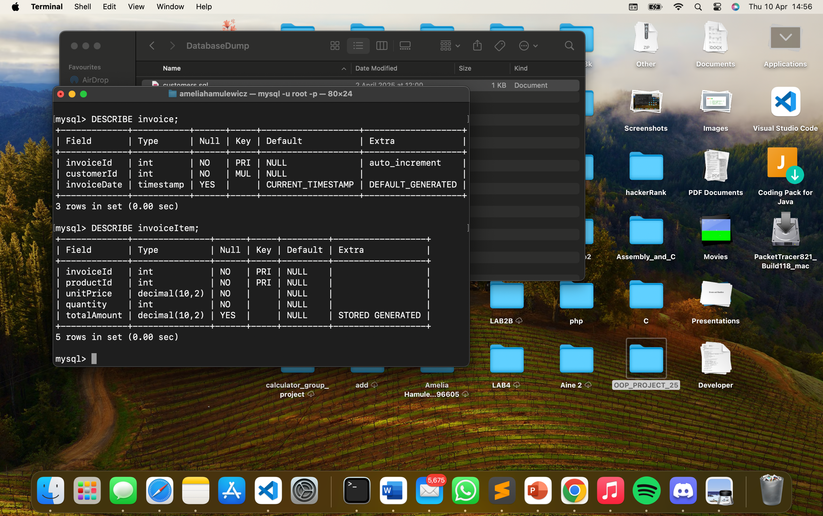

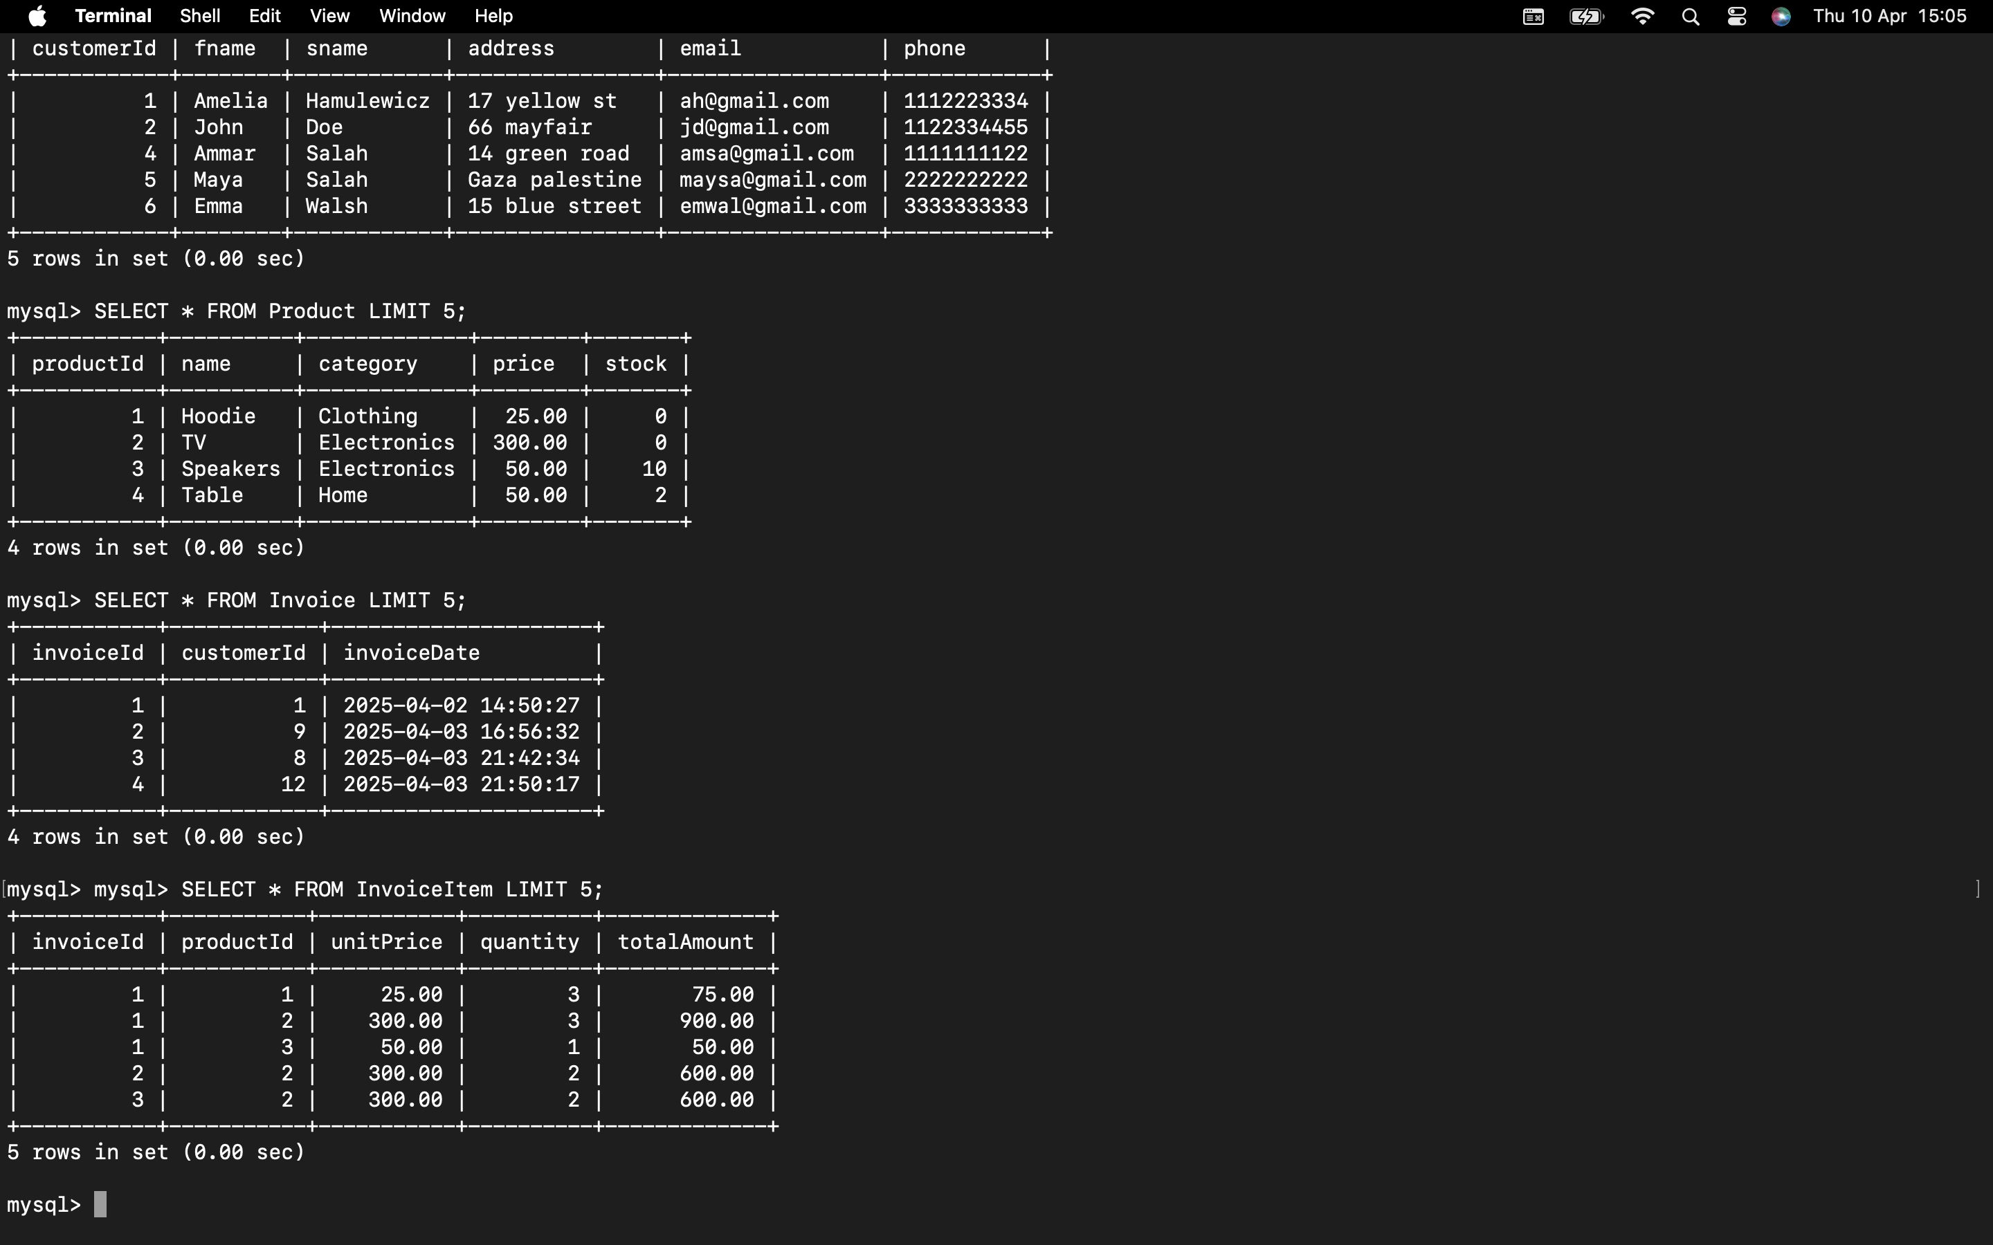

# **ER DIAGRAM**

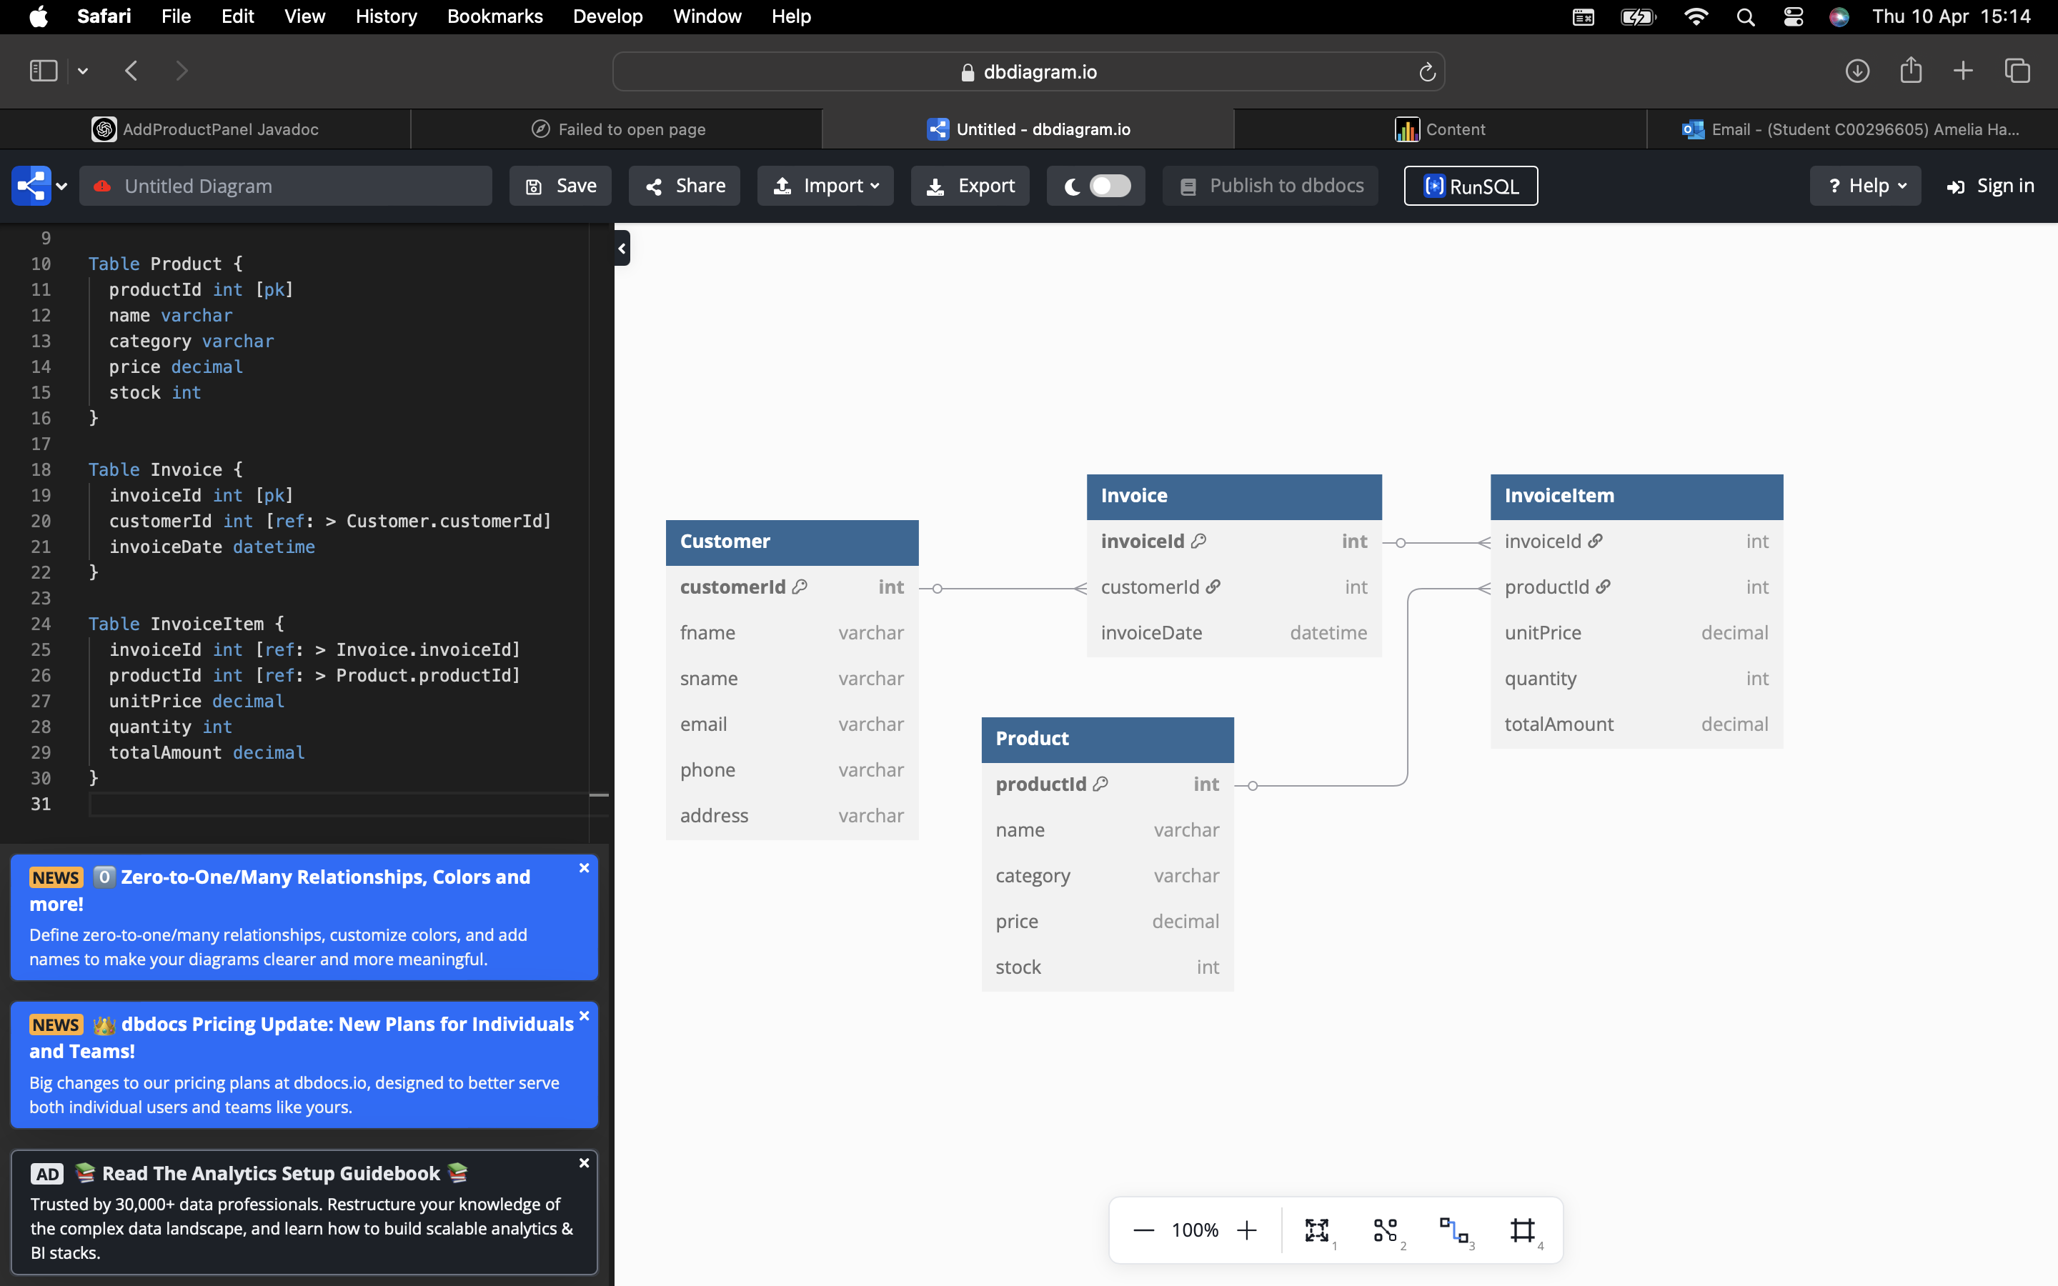

# **Interesting Source Code Snippets**

## **Validation**

Email Validation in Customer Object

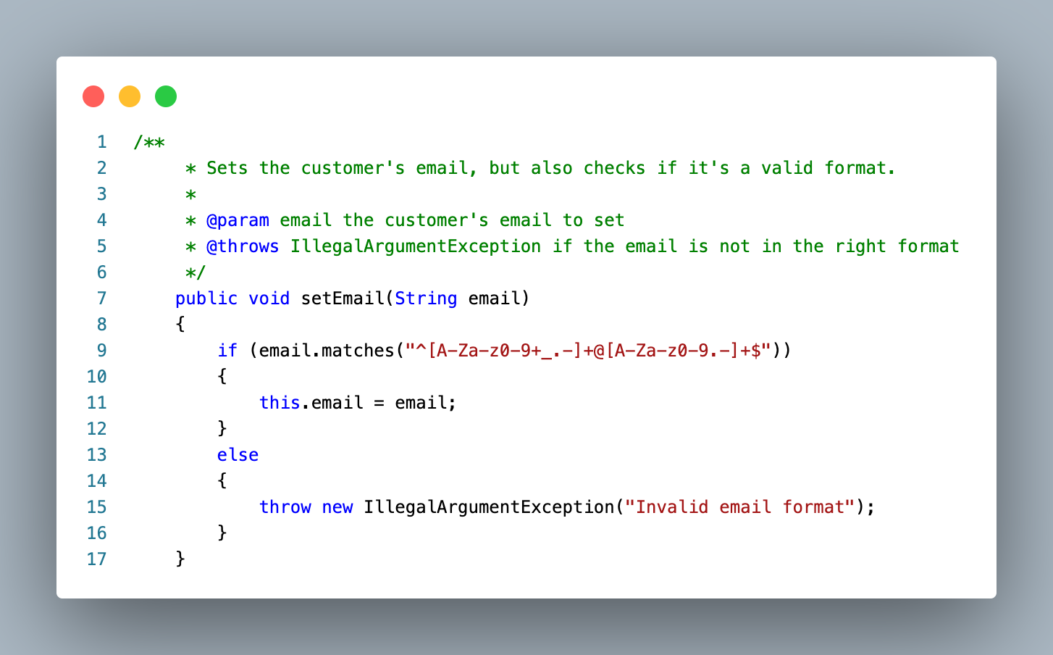

Phone Validation in Customer Object

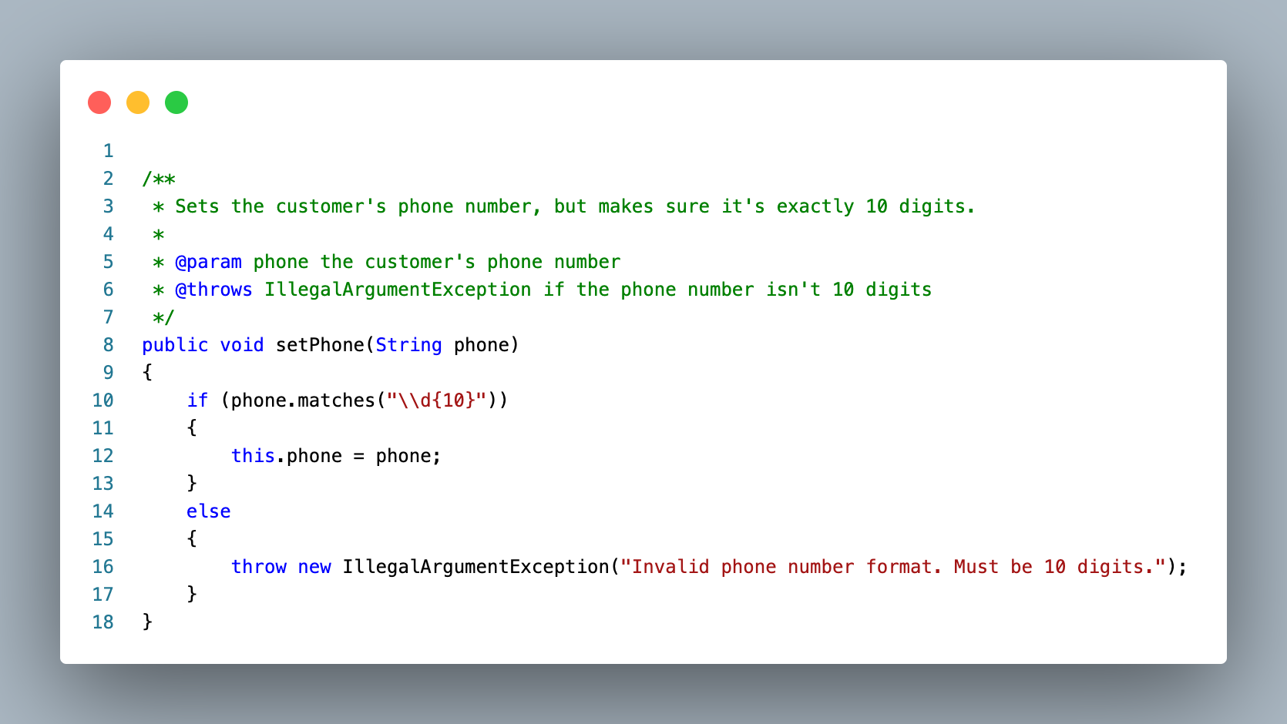

## Confirm Before Submission / Event handling GUI

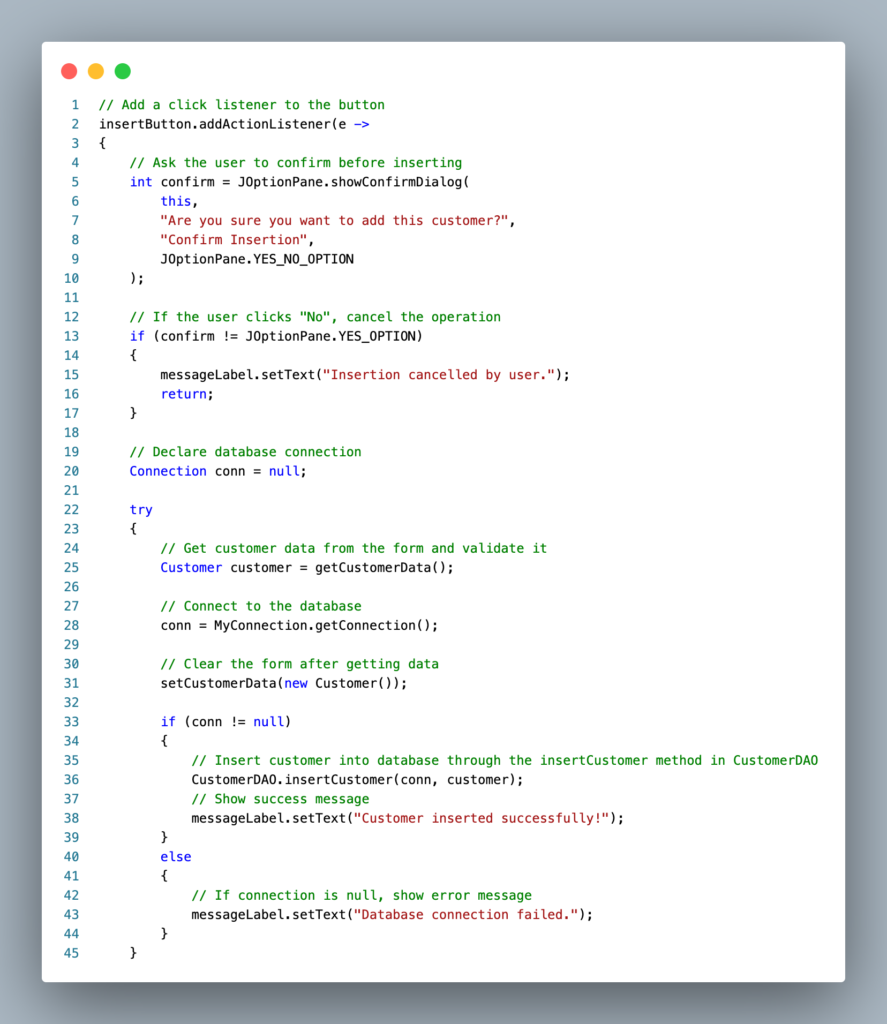

## Product Categories list dropdown

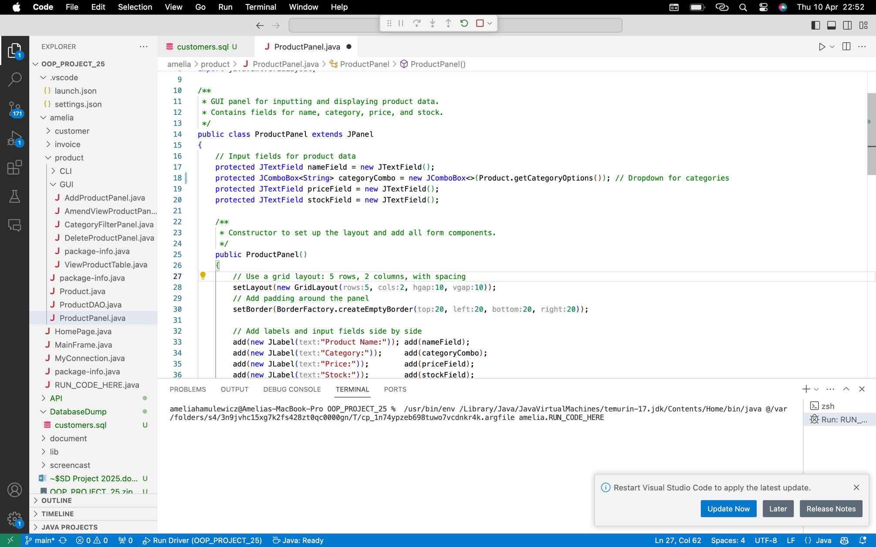

Default categories

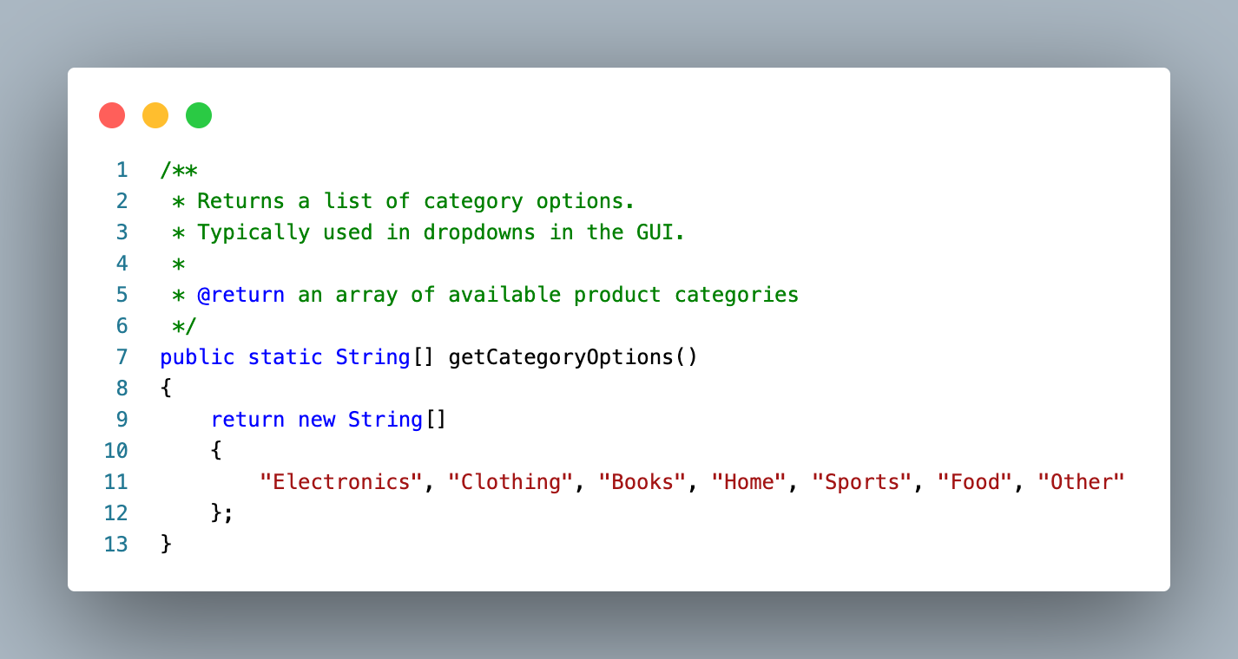

## Updating stock in the product table when item/s are added into invoice table:

Invoice DAO

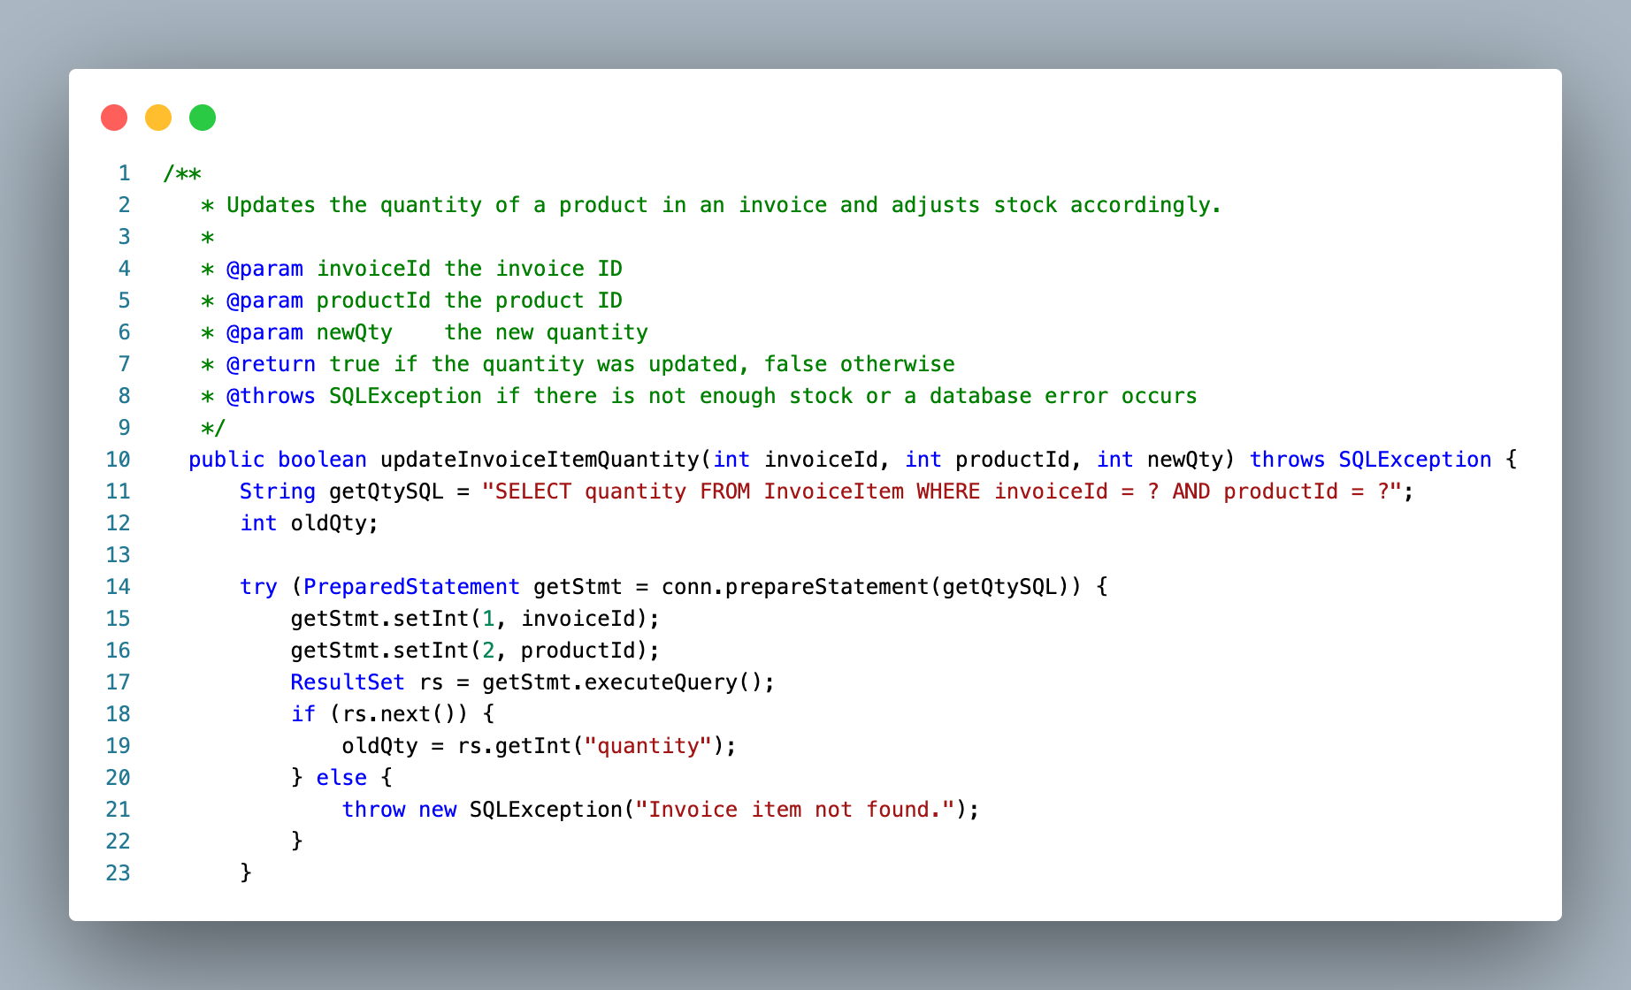

Add/ amend invoice items…

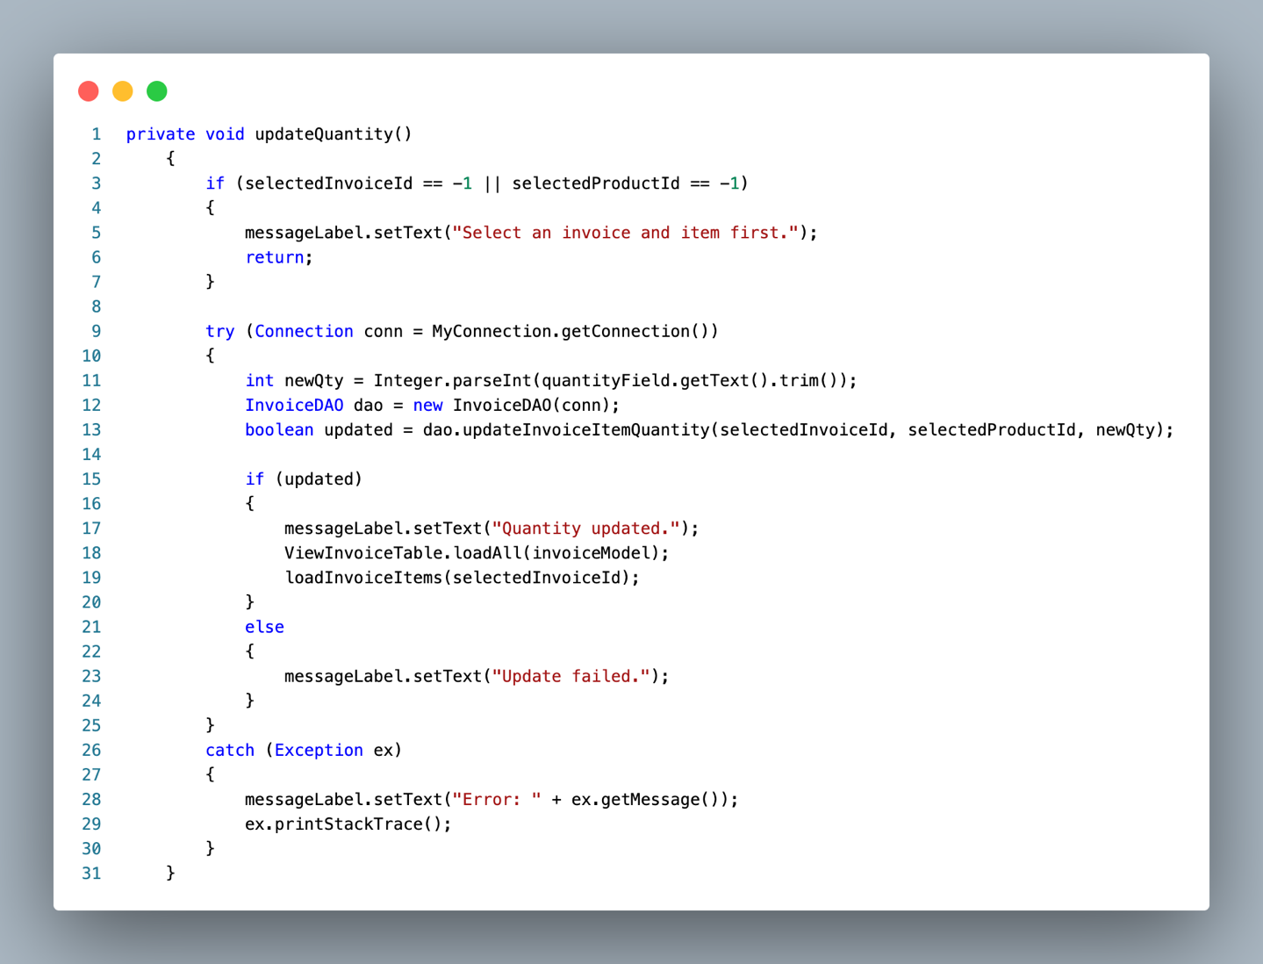

# **Tests**

* 1. **Product Management**

**Test: Add a new product**

* Entered valid name, category, price, and stock.
* Clicked 'Insert Product'.
* Product was saved to the database and showed up in the table.

**Test: Add product with negative price**

* Entered -5 for price.
* System showed a validation error: 'Price cannot be negative'.

**Test: Delete a product**

* Selected a product from the table.
* Clicked 'Delete Product'.
* Product was removed and table updated.
  1. **Customer Management**

**Test: Add new customer**

* Entered valid name, email, and phone.
* Customer was saved and displayed correctly.

**Test: Add customer with duplicate email**

* Entered same email as existing customer.
* System showed SQL error for duplicate email (as expected).

**Test: Edit customer**

* Selected a customer, changed details, and saved.
* Changes saved and updated in the table.
  1. **Invoice Management**

**Test: Create invoice with items**

* Selected a customer, added items from products.
* Invoice was created and total calculated.

**Test: Add item with too much quantity**

* Tried to add item with quantity higher than stock.
* System blocked it and showed 'Not enough stock'.

**Test: Delete an invoice**

* Selected invoice and clicked delete.
* Invoice and items were removed.
  1. **Input Validation & Error Handling**

**Test: Enter letters in price field**

* Typed 'abc' instead of a number.
* Error message shown: 'Please enter valid numbers'.

**Test: Leave fields empty**

* Tried to submit form without filling required fields.
* App showed validation messages and didn’t crash.
  1. **Filtering and Viewing**

**Test: Filter products by category**

* Selected 'Clothing' from category filter.
* Only clothing products shown.

**Test: View all invoices**

* Loaded invoice